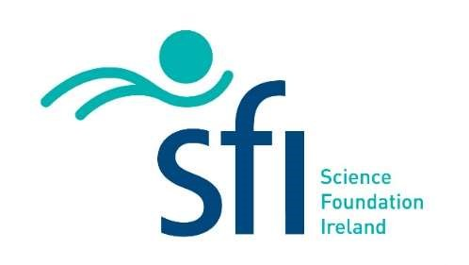

Role: PhD – Engineering design of a 6U Gamma-Ray Burst detecting CubeSat
Supervisor: Dr. David McKeown, University College Dublin (david.mckeown@ucd.ie)
We are seeking a highly motivated and skilled individual to join our team as a PhD student designing a 6U CubeSat in UCD School of Mechanical & Materials Engineering, Dublin, Ireland. The successful candidate will be responsible for the engineering design of the control systems of the Satellite as well as performing the structural, and thermal analysis before launch.
The successful applicant will also become part of a team of collaboratoer in the UCD school of Physics
Role
- Design and develop the control system, attitude determination and control systems (AOCS) and command and data handling (CDH) systems
- Conduct structural analysis to ensure the integrity and reliability of the spacecraft during launch and operation
- Perform thermal analysis to ensure that the spacecraft can withstand thermal environments in space and maintain the proper temperature for its components
- Collaborate with the team in developing and testing the CubeSat prototype
- Contribute to technical reports and presentations to communicate design decisions and results to stakeholders
The successful candidate will have the following:
- A minimum of a 2.1 Honours Bachelor’s degree in Mechanical, Aerospace or Electronic Engineering, or other relevant degree
- High standard of spoken and written English
- Ability to work to deadlines and work as part of an interdisciplinary team
- Undergraduate experience in control system design, structural analysis, and thermal analysis
- Experience in using simulation and analysis tools such as Matlab, Simulink, python, C (or other relevant programming languages) and FEA software
- Excellent problem-solving skills, attention to detail, and ability to work in a team environment
- Good communication and interpersonal skills

The successful applicant will join the Dynamics and Control Systems Group based in UCD School of Mechanical and Materials Engineering. The group has over 10 years of experience working of projects with the European Space Agency controlling the flexibility in space structures ranging from launchers, to X-ray telescopes and robotics arms.
The PhD is fully funded by Science Foundation Ireland for 4 years, with the Student receiving a tax free stipend of €18,500 per year. If you are passionate about space engineering and have a drive for innovation, we encourage you to apply for this exciting opportunity.
CubeSat mission
Gravitational waves were detected in 2015 for the first time. In 2017, gravitational waves from a binary neutron star merger were detected in coincidence with a gamma-ray burst (GRB) confirming that some short events are produced by mergers. The multi-messenger astrophysics era began, and the discovery highlighted the importance of space missions to detect and localise bursts at a time when gravitational wave systems are becoming more sensitive to merger events. Currently there is a lack of approved future gamma-ray missions to enable similar measurements and scientific discovery. Consequently we will build a 6U CubeSat called Gamma-ray Investigation of the Full Transient Sky or GIFTS.
The proposed design is based on detailed in-house instrument development and on the gamma-ray detector in the 2U CubeSat EIRSAT-1 which is due for launch in 2023.

To apply, please send a CV and cover letter to (david.mckeown@ucd.ie).
Applications will be considered up to 17th of March, 2023, with an expectation to start in May 2023, or as soon as possible thereafter.

